Movie Theater Management System - Database Model
This document describes the logical data model for Movie Theater Management System. It covers all entities, their attributes, inter-table relationships, sample data, and a 3NF compliance analysis.

1.1 Logical Scheme
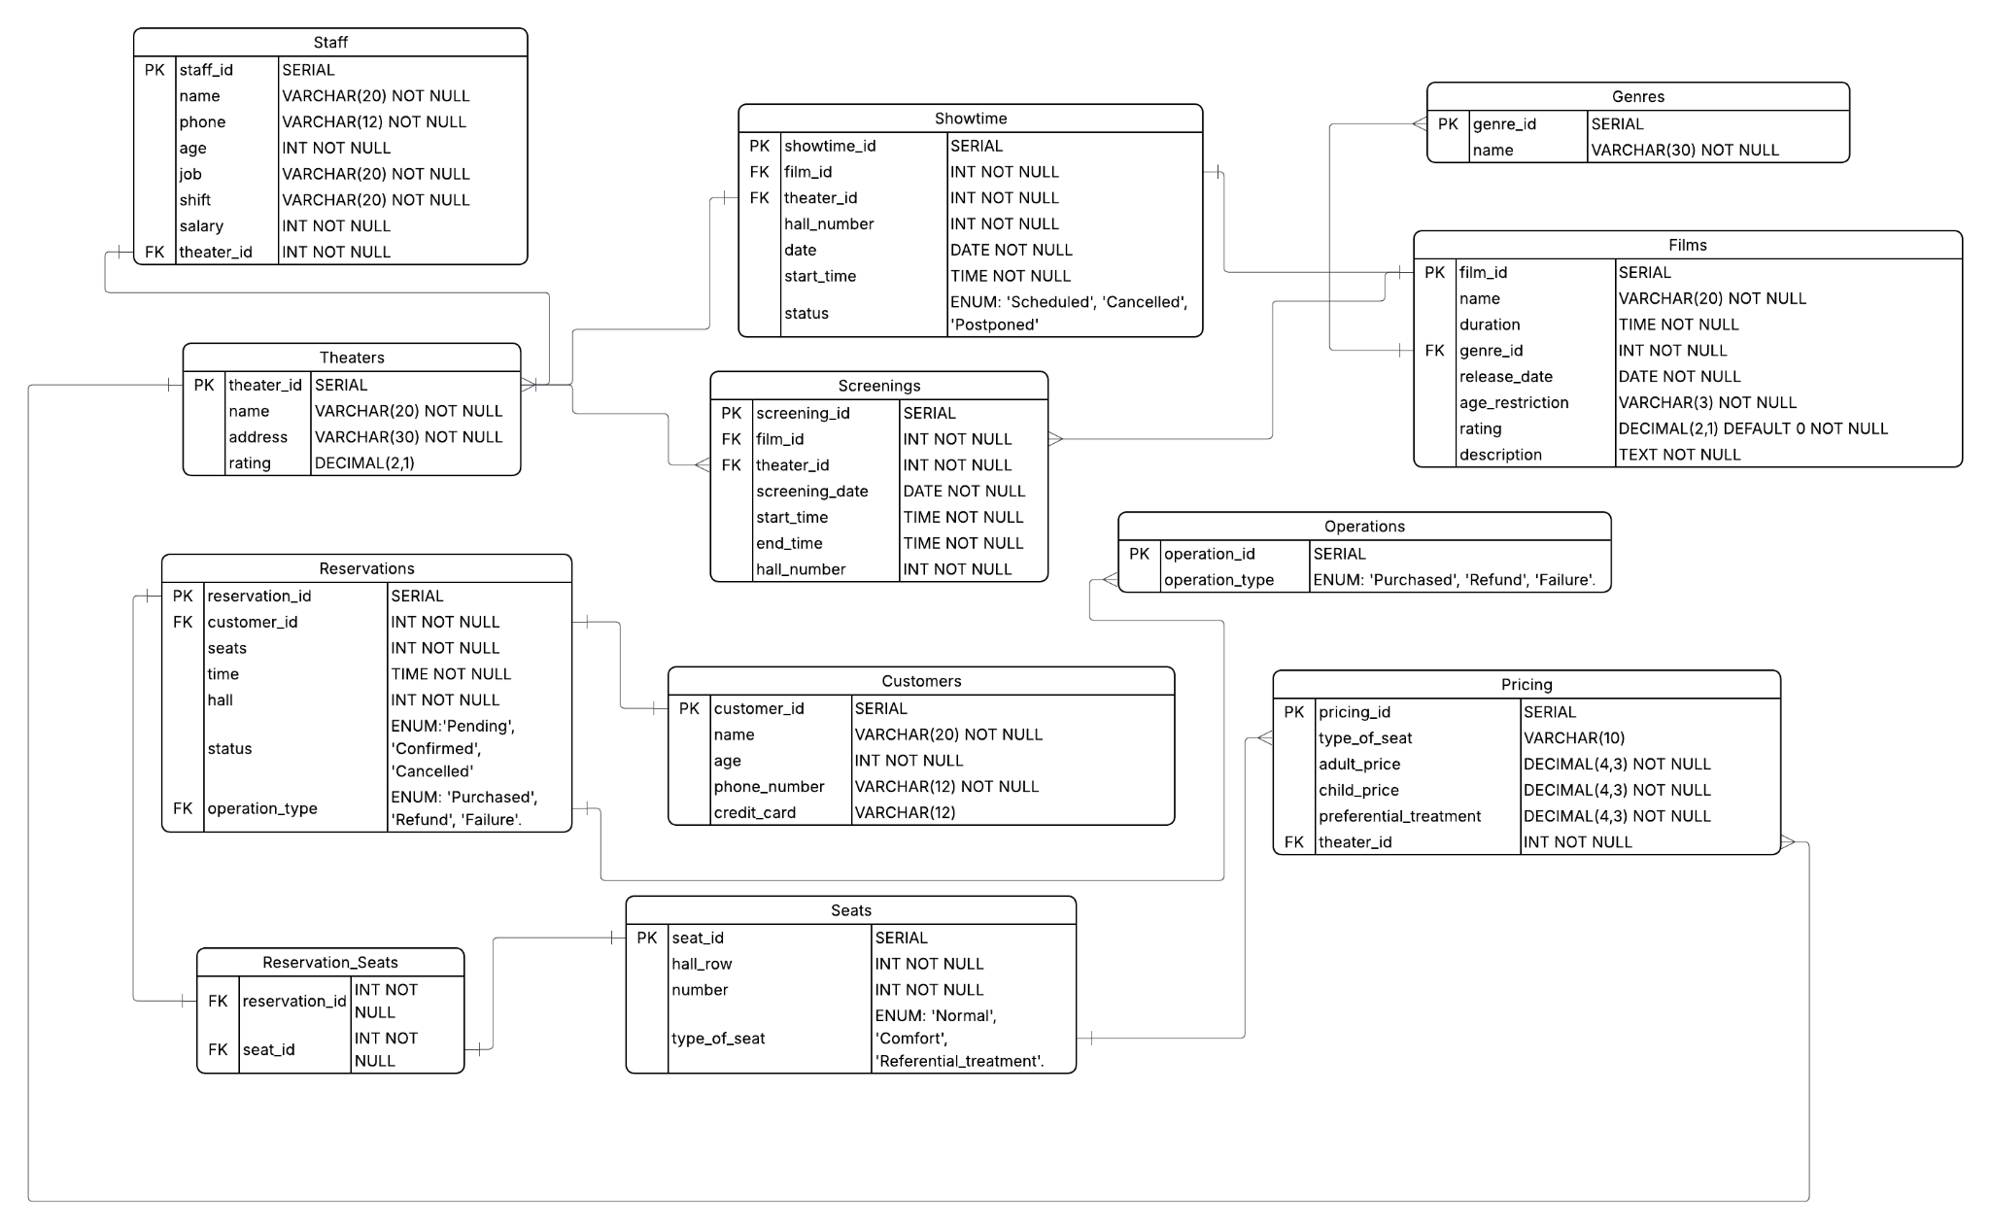

1.2 Objects
Table: Theaters
Table Description
The Theatres table stores information about each cinema venue in the system, including its official name, physical address, and average visitor rating. Each theater is uniquely identified by theater_id (SERIAL PRIMARY KEY). This table is the central anchor for staff assignments, showtimes, screenings, and pricing.

Table Name | Field name | Field Description | Data Type / Constraints
Theaters | theater_id | PK, auto-increment | SERIAL
 | name | Official name of the theater | VARCHAR(20) NOT NULL
 | address | Physical location, must be UNIQUE | VARCHAR(20) NOT NULL
 | rating | Average visitor rating | DECIMAL(2,1)

Comments on table relationships
One Theater has many Staff(Staff.theater_id → Theaters.theater_id). One Theater has many Showtimes(Showtime.theater_id → Theaters.theatter_id). One Theater has many Screenings(Screeings.theater_id → Theaters.theatter_id). One Theater has many Pricing records (Pricing.theater_id → Theaters.theatter_id).

Example with data

theater_id | name | address | rating
1 | Chaplin | Kazakhstan, Astana, Mega 2, 2nd floor | 4.8
2 | Kinopark 11 | Kazakhstan, Almaty, Dostyk Plaza | 4.6
3 | Silver Screen | Kazakhstan, Astana, Khan Shatyr | 4.7
4 | Lumiere | Kazakhstan, Almaty, Esentai Mall | 4.9
5 | CineStar | Kazakhstan, Shymkent, Mega Silk Way | 4.3
6 | Imax Plus | Kazakhstan, Astana, Park Mall | 4.5
7 | CineWorld | Kazakhstan, Karaganda, Galeria | 4.2
8 | Aurora | Kazakhstan, Aktau, Mega Center | 4.4

Table: Staff
Table Description
The Staff table records every employee working at a theater. Each record stores the employee’s full name, contact phone number, age, job, title, work shift, salary, and the theater they are assigned to. The theater_id foreign key links each employee one theater.

Table Name | Field name | Field Description | Data Type / Constraints
Staff | staff_id | PK, auto-increment | SERIAL
 | name | Full name of the employee | VARCHAR(50) NOT NULL
 | phone | Contact phone number UNIQUE | VARCHAR(12) NOT NULL
 | age | Employee’s age in years | INT NOT NULL
 | job | Job title\role | VARCHAR(50) NOT NULL
 | shift | Working shift (Morning, Evening, Night) | VARCHAR(20) NOT NULL
 | salary | Monthly salary in KZT | INT NOT NULL
 | theater_id | FK to Theaters | INT NOT NULL

Comments on table relationships
Many Staff belong to one Theater(Staff.theater_id → Theaters.theater_id). This is a many-to-one relationship theater can employ many staff members, but each staff member is assigned to one theater at a time.

Example with data

staff_id | name | phone number | age | job | shift | salary | theater_id
1 | Aibek Seitkali | +77011234567 | 28 | Casiher | Morning | 150000 | 1
2 | Zarina Bekova | +77011234568 | 34 | Manager | Evening | 280000 | 1
3 | Daniyar Umarov | +77011234569 | 22 | Usher | Night | 120000 | 2
4 | Ainur Zhaksylykbekova | +77011234570 | 31 | Projectionist | Morning | 200000 | 2
5 | Nursultan Karimov | +77011234571 | 45 | Security | Evening | 160000 | 3
6 | Madina Ospanova | +77011234572 | 27 | Cashier | Morning | 150000 | 3
7 | Yerlan Abenov | +77011234573 | 38 | Manager | Morning | 280000 | 4
8 | Saltanat Nurbayeva | +77011234574 | 29 | Manager | Morning | 120000 | 4

Table: Seats
Table Description
The Seats table describes every physical seat available across all halls. Each seat is identified by seat_id and characterized by its row number (hall_row), seat number within that row, and category (Normal, Comfort, or Referential_treatment). The seat type directly determines the applicable ticket price via the Pricing table. Seats are linked to reservations through the Reservation_seats junction table.

Table Name | Field name | Field Description | Data Type / Constraints
Seats | seat_id | PK, auto-increment | Serial
 | hall_row | Row number within the hall | INT NOT NULL
 | number | Seat number within the row | INT NOT NULL
 | type_of_seat | Seat category | ENUM: 'Normal', 'Comfort', 'Referential_treatment'.

Comments on table relationships
Many Seats are linked to many Reservations through the Reservation_seats junction table (Reservation_seats.saet_id → Seats.seat_id). The type_of_seat field corresponds to the same ENUM values used in Pricing.type_of_seat, enabling price look-up.
Example with data

seat_id | hall_row | number | type_of_seat
1 | 1 | 1 | Normal
2 | 1 | 2 | Normal
3 | 1 | 3 | Normal
4 | 2 | 1 | Comfort
5 | 2 | 2 | Comfort
6 | 2 | 3 | Comfort
7 | 3 | 1 | Referential_treatmant
8 | 3 | 2 | Referential_treatmant

Table: Customers
Table Description
The Customers table stores personal details about registered cinema-goers. Each customer record contains their full name, age, phone number, and credit number(stored for payment processing). The customer_id primary key uniquely identifies each registered user. Customers are referenced by the Reservations table when a booking is created.

Table Name | Field name | Field Description | Data Type / Constraints
Customers | customer_id | PK, auto-increment | Serial
 | name | Full name of the customer | VARCHAR(50)
 | age | Customer’s age | INT
 | phone | Phone number | VARCHAR(12)
 | credit_card | Card number used for payments | VARCHAR(12)

Comments on table relationships
One customer can make many reservations (Reservations.customer_id → Customers.customer_id). This is a one-to-many relationship: a single customer may have multiple booking records over time.
Example with data

customeer_id | name | age | phone | credit_card
1 | Aman Belov | 25 | +7028049823 | 440023409899
2 | Dina Suleimanova | 32 | +7028049826 | 440023409832
3 | Marat Dxhaksylykov | 28 | +7028049825 | 440023409815
4 | Aigerim Nurlanova | 21 | +7028049823 | 440023409814
5 | Kamila Ospanova | 29 | +7028049129 | 440023409813
6 | Ruslan Berdibayev | 42 | +7028049912 | 440023409812
7 | Assel Namazalieva | 17 | +7028049822 | 440023409817
8 | Nurdana Khalelkyzy | 18 | +7028049821 | 440023409821

Table: Genres
Table Description
The Genres table is a reference table that defines the categories used to classify films. Each genre has a unique name. The genre_id referenced as a foreign key in the Films table, ensuring genre data is stored in one place.
Table Name | Field name | Field Description | Data Type / Constraints
Genres | genre_id | PK, auto-increment | Serial
 | name | Name of the film genre | VARCHAR(50) NOT NULL

Comments on table relationships
One Genre is associated with many Films(Films.genre_id → Genres.genre_id). This is a one-to-many relationship: each film belongs to one genre, but a genre can classify many films.
Example with data

genre_id | name
1 | Action
2 | Comedy
3 | Drama
4 | Thriller
5 | Animation

Table: Films
Table Description
The Films table stores the catalogue of movies available for screening. Each record includes the title, runtime in minutes, genre reference, release date, minimum age restriction, average critic/audience rating, and a short plot description. The genre_id FK links each film to its genre. Films are referenced by both the Showtime and Screening tables.

Table Name | Field name | Field Description | Data Type / Constraints
Films | film_id | PK, auto-increment | Serial
 | name | Film title | VARCHAR(50)
 | duration | Runtime in minutes | INT NOT NULL
 | genre_id | FK to Genres | INT NOT NULL
 | release_date | Official release date | DATE
 | age_resctriction | Minimum viewer age (e.g. 12+) | VARCHAR(5)
 | rating | Average rating | DECIMAL(2,1)
 | description | Short plot synopsis | TEXT

Comments on table relationships
One Film to one Genre(Films.genre_id → Genres.genre_id). One Film can have many Showtimes and Screenings.
Example with data

film_id | name | duration | genre_id | release_date | age_restriction | rating
1 | The Lion King | 118 | 8 | 2019-07-21 | 0+ | 4.7
2 | Avengers: Endgame | 181 | 1 | 2019-04-25 | 12+ | 4.3
3 | The Dark Knight | 152 | 7 | 2008-07-18 | 16+ | 4.6

Table: Showtime
Table Description
The Showtime table represents the planned schedule of film screenings across theaters. Each record defines which film is screened, at which theater and hall, on what date and start time, and whether the showing is Scheduled, Cancelled, or Postponed. This table drives the public-facing timetable displayed to customers.

Table Name | Field name | Field Description | Data Type / Constraints
Showtime | showtime_id | PK, auto-increment | Serial
 | film_id | FK to Films | INT NOT NULL
 | theater_id | FK to Theaters | INT NOT NULL
 | hall_number | Hall number within the theater | INT NOT NULL
 | date | Date of the showing | DATE
 | start_time | Scheduled start date-time | TIMESTAMP NOT NULL
 | status | Current status of the showtime | ENUM(‘Scheduled’, ‘Cancelled’, ‘Postponed’)

Comments on table relationships
One Showime references one Film, Theater_id. One Showtime may correspond to one Screening record once the event has started.
Example with data

showtime_id | film_id | theater_id | hall_number | date | start_time | hall_number
1 | 1 | 1 | 1 | 2024-05-10 | 2024-05-10 14:00 | Scheduled
2 | 2 | 1 | 2 | 2024-05-10 | 2024-05-10 17:30 | Scheduled
3 | 3 | 2 | 1 | 2024-05-12 | 2024-05-12 20:00 | Cancelled

Table: Screenings
Table Description
The Screenings table record the actual execution of film showing. Unlike Showtime, Screenings captures the confirmed start and end times of a showing that has taken place or is currently runnnig. It also stores the hall number used. This separation supports historical reporting and analytics independent of schedule changes.

Table Name | Field name | Field Description | Data Type / Constraints
Screenings | screenig_id | Identifier, PK | Serial
 | film_id | FK to Films | INT NOT NULL
 | theater_id | FK to Theaters | INT NOT NULL
 | screening_date | Date of the screenig | DATE NOT NULL
 | start_time | Actual start time | TIMESTAMP NOT NULL
 | end_time | Actual end time | TIMESTAMP NOT NULL
 | hall_number | Hall used for the screening | INT NOT NULL

Comments on table relationships
One Screening references one Film, Theater. Screenings complement Showtime records: a Showtime with status ‘Scheduled’ may generate a Screening entry once the event begins.
Example with data

screenig_id | film_id | theater_id | screenig_date | start_time | end-time | hall_number
1 | 1 | 1 | 2024-05-10 | 2024-05-10 14:00 | 2024-05-10 16:46 | 1
2 | 2 | 2 | 2024-05-10 | 2024-05-10 17:30 | 2024-05-10 19:30 | 2
3 | 3 | 3 | 2024-05-10 | 2024-05-10 20:00 | 2024-05-10 22:28 | 1

Table: Reservations
Table Description
The Reservations table tracks every booking timestamp, which hall is involved, the current status, and the payment operatiom type. The opearion_id field mirrors the Operation table, for strict normalization it should be replaced with a FK to Operations.

Table Name | Field name | Field Description | Data Type / Constraints
Reservations | reservation_id | Identifier, PK | Serial
 | customer_id | FK to Customers | INT NOT NULL
 | seats | Number of seats reserved | INT NOT NULL
 | time | Date-time when the reservation was created | TIMESTAMP NOT NULL
 | hall | Hall number for the reservation | INT NOT NULL
 | status | Reservation status | ENUM(‘Pending’, ‘Confirmed’, ‘Cancelled’)
 | opeartion_type | Payment operation resultt | ENUM(‘Purchased’, ‘Refund’, ‘Failure’)

Comments on table relationships
Many reservations belong to one customer. One reservation can include many seats.
Example with data

reservation_id | customer_id | seats | time | hall | status | opearion_type
1 | 1 | 2 | 2024-05-10 13:30 | 1 | Confirmed | Purchased
2 | 2 | 3 | 2024-05-10 17:00 | 2 | Confirmed | Purchased
3 | 3 | 1 | 2024-05-10 09:45 | 2 | Cancelled | Refund
4 | 4 | 4 | 2024-05-10 19:20 | 1 | Pending | Failure

Table: Reservation_seats
Table Description
Reservation_seats is a bridge table that resolves the many-to-many relationship between Reservations and Seats. Each row represents one specific seat assigned to one reservation. The composite PK is (reservation_id, seat_id). This design allows a single reservation to span multiple seats and avoid repeating seat listws inside the Reservation table.

Table Name | Field name | Field Description | Data Type / Constraints
Reservation_seats | reservation_id | FK to Reservations, part of composite PK | INT NOT NULL
 | seat_id | FK to Seats, part of composite PK | INT NOT NULL

Comments on table relationships
Each row referenced one reservation and one seat. Both columns form the composite PK, preventing duplicate seat assigned within the same reservation.
Example with data

reservation_id | seat_id
1 | 4
1 | 5
2 | 1

Table: Operations
Table Description
The Operations table is a reference table defining the three possible payment operation results Purchased, Refund, and Failure. By isolating these values in their own table, the system avoids scattering ENUM definitions across multiple tables and allows future addition of new operation types without schema changes.

Table Name | Field name | Field Description | Data Type / Constraints
Operations | operation_id | Identifier, PK | Serial
 | operation_type | Label for opeartion | VARCHAR(20) NOT NULL

Comments on table relationships
One operation record can be referenced by many Reservations.
Example with data

operation_id | operation_type
1 | Purchased
2 | Refund
3 | Failure

Table: Pricing
Table Description
The Pricing table defines the ticket price matrix for each theater, broken down by seat type and customer. Each row represents a one-seat-type price tier in one theater.

Table Name | Field name | Field Description | Data Type / Constraints
Pricing | pricing_id | Identifier, PK | Serial
 | type_of_seat | Seat category | ENUM: 'Normal', 'Comfort', 'Referential_treatment'.
 | adult_price | Full adult ticket price in KZT | DECIMAL(8, 2) NOT NULL
 | child_price | Child ticket price in KZT | DECIMAL(8, 2) NOT NULL
 | theater_id | FK | INT NOT NULL

Comments on table relationships
Each pricing record references one theater. The type_of_seats values match Seats.type_of_seat, allowing the system to look up the correct price when a reservation is confirmed.
Example with data

pricing_id | type_of_seat | adult_price | child_price | theater_id
1 | Normal | 1500.00 | 800.00 | 1
2 | Comfort | 2000.00 | 1700.00 | 2
3 | Referential_treatment | 1200.00 | 600.00 | 3
4 | Comfort | 2000.00 | 1700.00 | 4

